# How to use the application

## Step 1: Run database script

### Find script instructions in project folder/database script.txt.

### This will set up the database and required tables.

### This will also insert user login details of user administrator.

## CHANGE THE PASSWORD TO YOUR OWN MYSQL PASSWORD

### Change the password to your own one in the hibernate configuration file.

## Login into the application

### Use Admin as both username and password.

### 

## add new subject

### Press add subject navigation link and enter subject details and then press add subject.

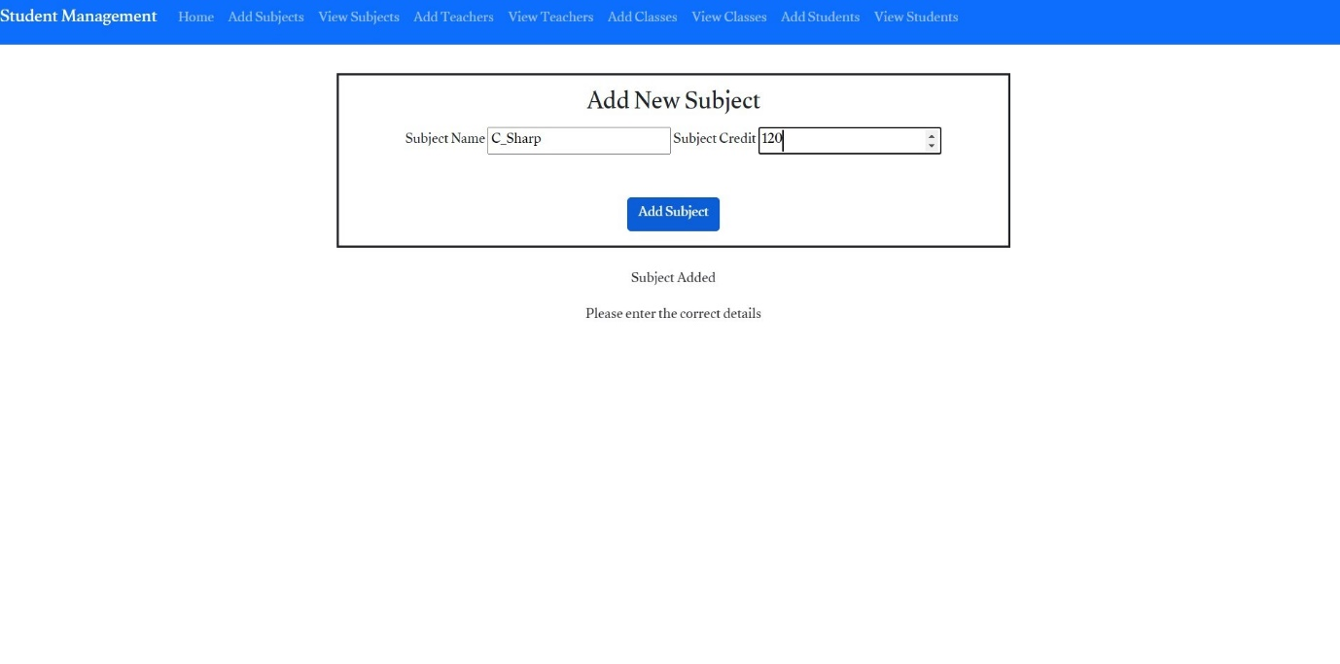

### Verification of subject insertion

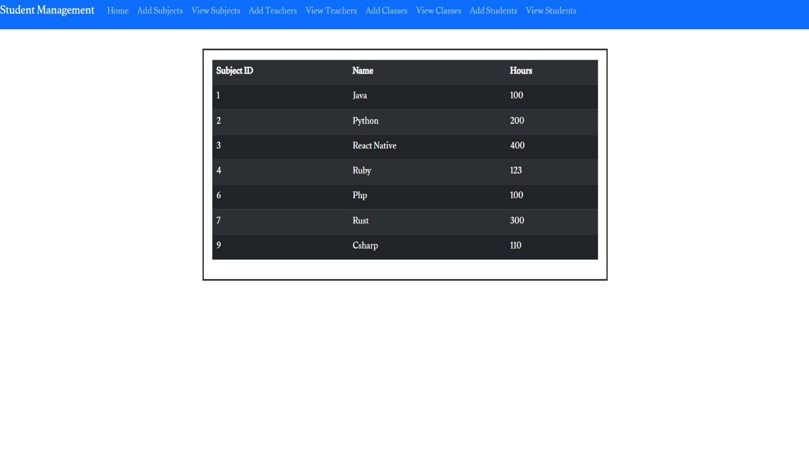

## Add a lecture associated with a subject

### Use Add Teacher navigation link to navigate to the add teacher page, then enter all the necessary information and press add teacher button to save the information to the database.

